Community Health Survey Summary
  - Wayne County, Ohio June 2019
The purpose of this survey was to get community members’ opinions about community health problems in Wayne County. The Wayne County Health Department will the results of this survey and other information to identify the most pressing problems which can be addressed through community action.

Respondents
The Community Health Survey was administered electronically through email and social media and paper copies were handed out by the Health Department. The survey was open from May 31, 2019 – June 26, 2019. There were 309 responses from 17 of the 23 zip codes in the county. Responses were received from all age groups with 33.9% being from those aged 40-54 and 29.3% from those aged 26-39. 97.7% of the respondents identify as White/Caucasian, which is in line with county demographics (94% white, censusreporter.org)¹. The household income of the respondents spanned from less than $20,000 to over $100,000 and was fairly evenly distributed.

Findings
When asked about the most important factors for a “Healthy Community” the most common answer was low crime/safe neighborhood with 50% of respondents choosing this answer. The other most popular answers were good jobs and healthy economy, access to healthcare, and good schools.
Figure 1. Important Factors for "Healthy Community"

Access to healthcare has been a recurring topic in community discussions in the past several years and was the 4th most common answer when it comes to important factors for a “Healthy Community”. Therefore, the survey also asked about the issues that prevent those in the community from accessing health care. 38.3% responded that times aren’t convenient, 29.8% responded fear (not ready to face/discuss health problems), and 29.4% responded that no insurance and/or unable to pay for care is the reason they do not access healthcare.
Figure 2. Barriers to Healthcare.

When asked about the most important “health problems” in our community the number one response was mental health problems (67%), followed by cancers (37.6%) and child abuse/neglect (32.7%).
Figure 3. Important "Health Problem"

The community was asked about what they believe are the behaviors that are the most important “risky behaviors” (the behaviors which have the greatest impact on overall community health), the largest response was for drug abuse with 61.7% of the responses, alcohol abuse came in next at 48.8%, and the third highest was being overweight at 36.0%.
Figure 4. Risky Behaviors.

“Health Problems” How We Compare

Mental Health
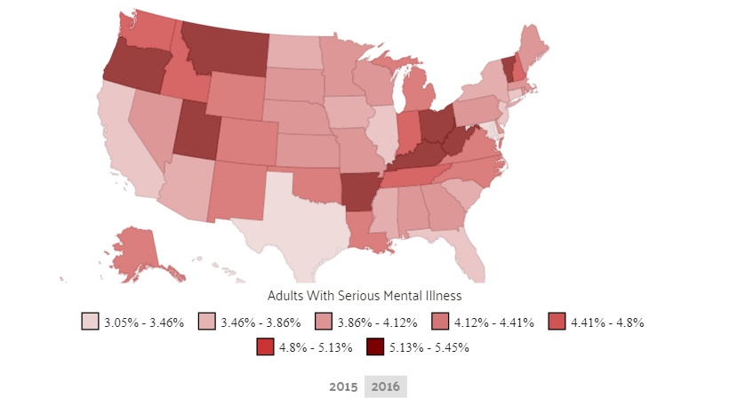
Mental Health was voted as the number one “health problem” in the county by the respondents. One of the reasons mental health may be a perceived health problem is the lack of mental health providers. Though Wayne County has a greater number of providers per patient (320:1) than the state (470:1) it is still very high. Meaning mental health providers see a significant amount of patients per year, approximately 342 patients.² Ohio is one of the states with the highest prevalence of adults with serious mental health illness at 5.13%.

Cancers
Cancer was determined by the survey respondents to be the second largest “health problem” in the community. The incidence rate of cancer in Wayne County is 427.2, which is lower than the incidence rate of cancer in the state of Ohio (456.1).⁴ The top 3 cancers in the state of Ohio are breast, lung & bronchus, and prostate. The top 3 cancers in Wayne County are lung & bronchus, breast, and prostate. Cancer is the second leading cause of death in the U.S. exceeded only by heart disease. The cancer death rate for all of Ohio is 173.5. The cancer death rate for Wayne County is 163.6, which is just above the Healthy People 2020 target of 161.4.³

Child Abuse/Neglect
Child abuse/neglect was voted as the third largest “health problem” in the community. Child abuse and neglect can have severe consequences for the child physically, mentally, and social developmentally. It can increase the risk for chronic disease such as heart disease, cancer, liver disease, obesity, high blood pressure, chronic lung disease, and high cholesterol. It creates a higher risk for mental health diagnoses and learning disorders and can lead to higher risk of juvenile delinquency and adult criminal behavior. In 2016, the state of Ohio received 97,602 children services reports for child abuse or neglect.⁵

Substance Abuse
Alcohol and Drug abuse were the top answer for most important “risky behavior” in the community. Wayne County has a drug overdose mortality rate of 25, which is lower than the state of Ohio which has a rate of 37. Which are both much greater than the top performing counties in the U.S. for this measure which have rates of 10.² Last year Wayne County had 289 drug overdose cases and as of June 1, 2019 there have been 129 drug overdoses in the county. Wayne county currently has many agencies and coalitions working towards decreasing substance abuse in the community.

Obesity
Being overweight was the third most common answer for “risky behaviors” in the community. The percentage of the population that is obese in Wayne County is 30%, which is down 2% from the state of Ohio which has 32% obesity.² Obesity has been on the rise in the past and came to a peak in 2009 and then declined a bit and rose again in 2013. Since 2013, the county has been holding at about 30%, which hits the Healthy People 2020 target of 30.5%.³

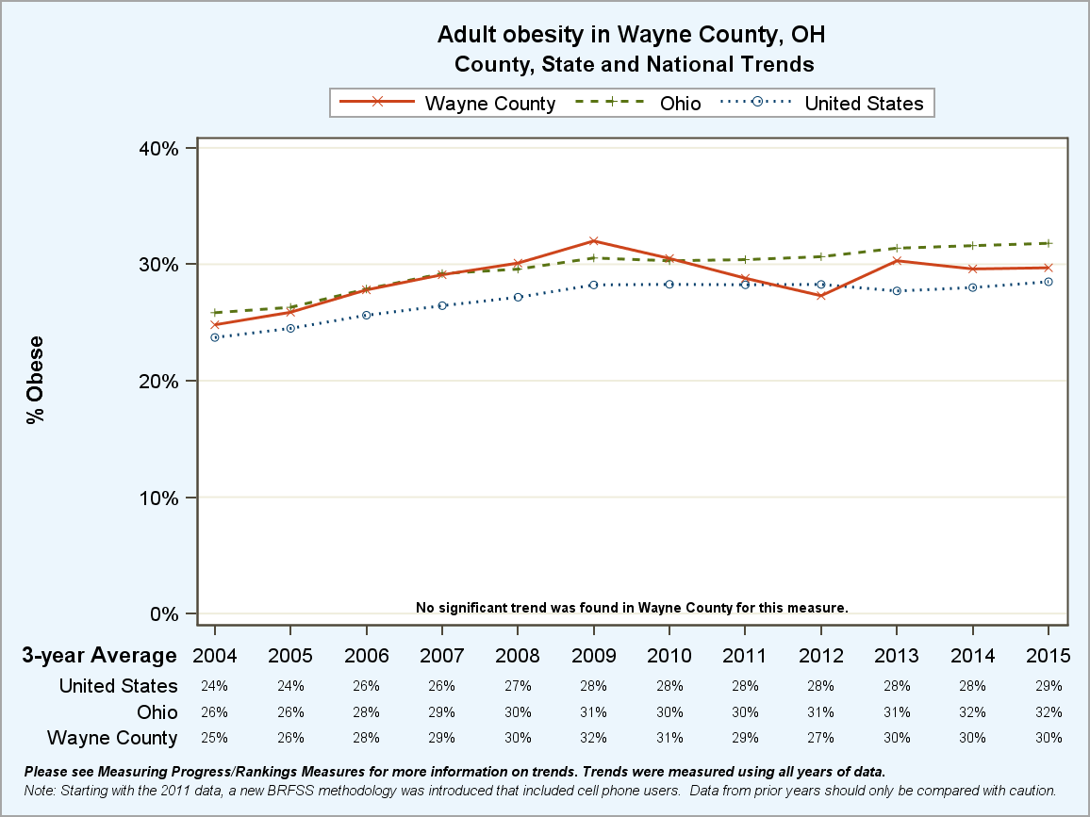
Figure 5. Obesity Trends

References
¹U.S. Census Bureau (2017). American Community Survey 1-year estimates. Retrieved from Census Reporter Profile page for Wayne County, OH http://censusreporter.org/profiles/05000US39169-wayne-county-oh/
²County Health Rankings and Roadmaps (2019). Retrieved from www.countyhealthrankings.org/app/ohio/2019/rankings/wayne/county/outcomes/overall/snapshot
³Healthy People 2020 (2014). Office of Disease Prevention and Health Promotion. Retrieved from https://www.healthypeople.gov/2020/topics-objectives/topic/nutrition-and-weight-status/objectives
⁴State Cancer Profiles (2019). National Cancer Institute. Retrieved from https://statecancerprofiles.cancer.gov/incidencerates/index.php?stateFIPS=39&cancer=001&race=00&sex=0&age=001&type=incd&sortVariableName=rate&sortOrder=default#results
⁵Ohio Child Abuse and Neglect Statistics (2018). Ohio Children’s Trust Fund: Ohio’s Prevent Child Abuse America Chapter. Retrieved from https://octf.ohio.gov/wps/portal/gov/octf/what-we-do/the-problem/ohio-child-abuse-and-neglect-stats.

