Materials accepted at each Household Hazardous Waste collection event

AEROSOLS
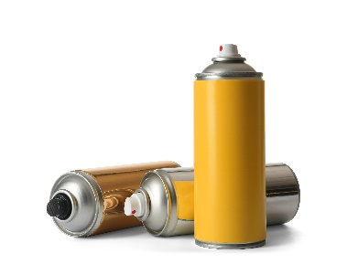
Aerosol spray cans contain product and propellant under pressure that can be dispensed as a spray, mist, or foam. Common aerosol can products include insecticides, cooking sprays, solvents, and paints.

AUTOMOTIVE FLUIDS
Some car fluids such as Motor Oil, Break Fluid, Antifreeze, Transmission Fluid, Power Steering Fluid, or Windshield Wiper Fluid can be processed and recycled into new fluids.

These type of liquids are considered hazardous and therefore they must be stored and disposed of properly.
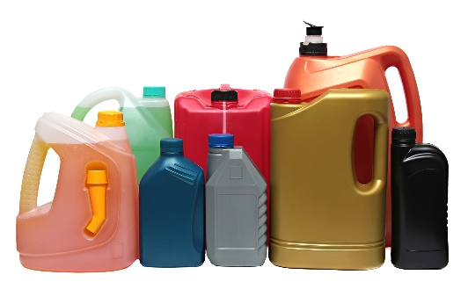

DIESEL, KEROSENE & GASOLINE 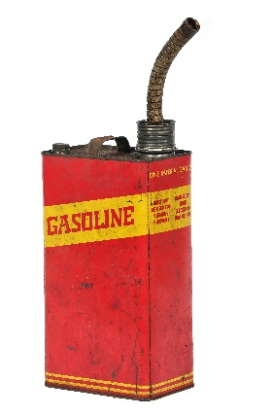
A limit of 10 gallons per car with tightly closed containers.

The containers will NOT be returned.
CLEANING SUPPLIES & OTHER HOUSHOLD CHEMICALS
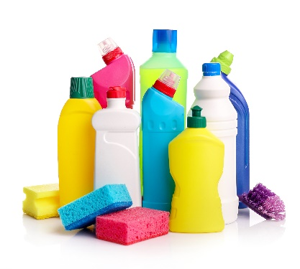
****Never mix bleach or any bleach-containing product with any cleaner containing ammonia. The gases created from this combination can lead to chronic breathing problems and even death****

Household hazardous chemicals like Oven cleaners, Chlorine Bleach, Ammonia, Rug and Upholstery Cleaners, Furniture and Floor Polish are accepted at each HHW event.

FLUORESCENT BULBS

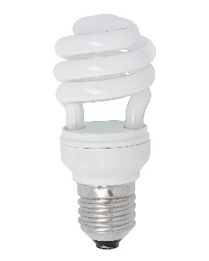
All fluorescent tubes up to 8 foot and CFL bulbs will be accepted at each event.

MERCURY CONTAINING DEVICES

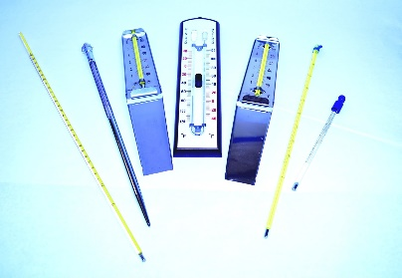
Some products such as Thermometers, Barometers, Flow meters, contain Mercury and must be disposed of correctly. We accept all types of items that contain mercury at each event.

OIL-BASED PAINTS ONLY
**NO LATEX PAINT WILL BE ACCEPTED!**
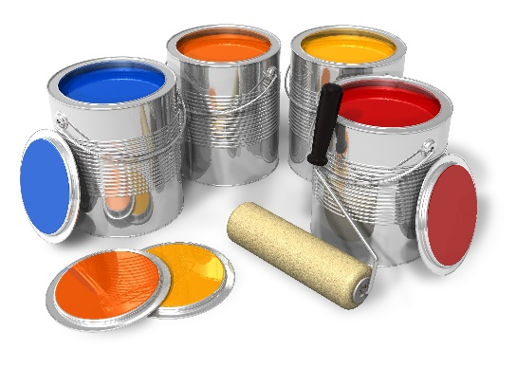
To tell the difference between Latex Paints and Oil-based Paints:
On the manufactures label on the back of the can look for the “clean-up” instructions
If it says to clean with soap and water, you have a latex or water based paint
If it says to clean with a solvent or paint thinner, you have an oil-based paint

Latex Paint Disposal:

- Dry it out using kitty litter, sand or newspaper.

- After it is dried out, dispose in the trash

PESTICIDES, HERBICIDES & FUNGICIDES
All types of pesticides, herbicides and fungicides are accepted at each HHW event.
These type of chemicals are poisonous they are used to prevent, destroy or repel pests.

Pests can be insects, mice or other animals, weeds, fungi, or microorganisms such as bacteria and viruses.

**Do NOT place them in your trash can, put them down any drain bury or burn them!**

