Rabies - Dogs & Cats
What happens if your dog or cat bites someone?
- Any bite/exposure is required to be reported to the Wayne County Health Department.

- The Wayne County Health Department is not going to take the dog/cat. away from the owner.

- If the victim seeks medical treatment, the medical provider is required to have a Bite Report completed and sent to WCHD.
- The dog, cat, etc. is required to be quarantined – which simply means to be kept away from the public – for 10 days.

- The goal of the Health Department is to make sure that dogs/cats remain healthy throughout the quarantine period.

- The dog, cat, etc. is required to be taken to the Vet. after the 10th day to have a Good Health Certificate completed so that the GHC can be sent to WCHD.

- If the dog/cat/ does not have a current Rabies vaccination they will need to be given a Rabies vaccination (unless they are too young to be vaccinated or have other health issues).

The Ohio Administrative Code (OAC) requires that all animal bite and exposure incidents are reported to WCHD within 24 hours.

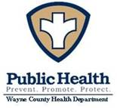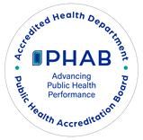

Wayne County Health Department
Environmental Health Division
428 W. Liberty Street
Wooster, OH 44691

